**JUnit Basic Testing Exercises**

**Exercise 1: Setting Up JUnit**  
**Scenario:**  
You need to set up JUnit in your Java project to start writing unit tests.

**Steps:**

1. Create a new Java project in your IDE (e.g., IntelliJ IDEA, Eclipse).
2. Add JUnit dependency to your project. If you are using Maven, add the following to your pom.xml:

<dependency>

<groupId>junit</groupId>

<artifactId>junit</artifactId>

<version>4.13.2</version>

<scope>test</scope>

</dependency>

3.Create a new test class in your project.

**SOLUTION:**

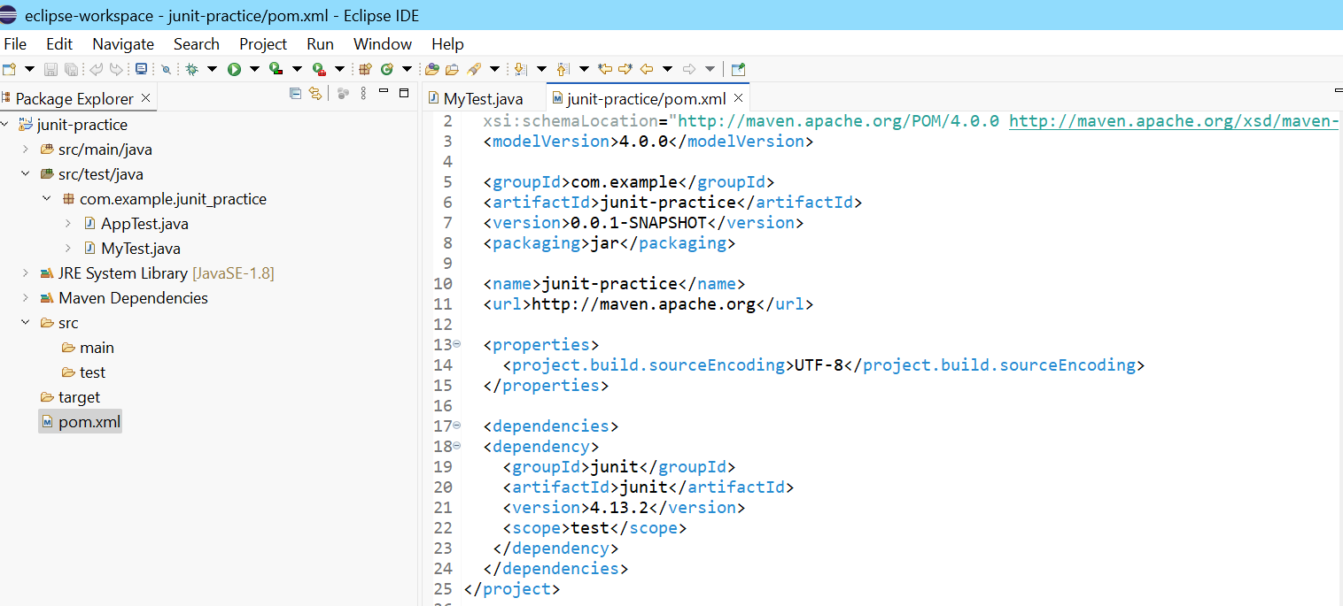

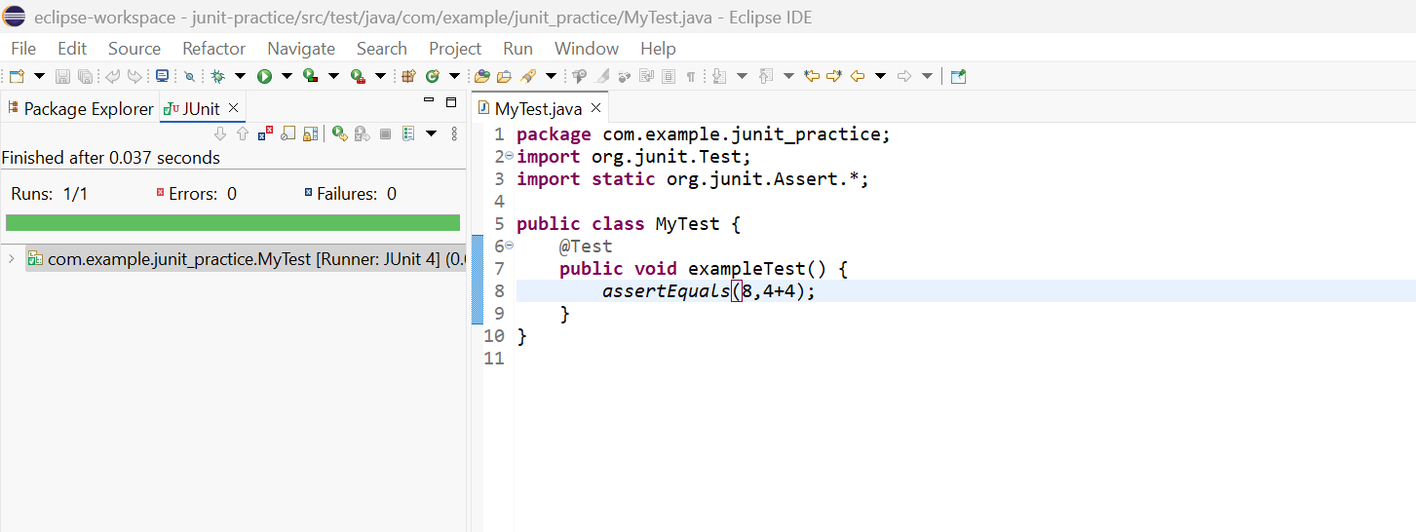

**Exercise 3: Assertions in JUnit  
Scenario:**You need to use different assertions in JUnit to validate your test results.

Steps:

1. Write tests using various JUnit assertions.

**SOLUTION:**

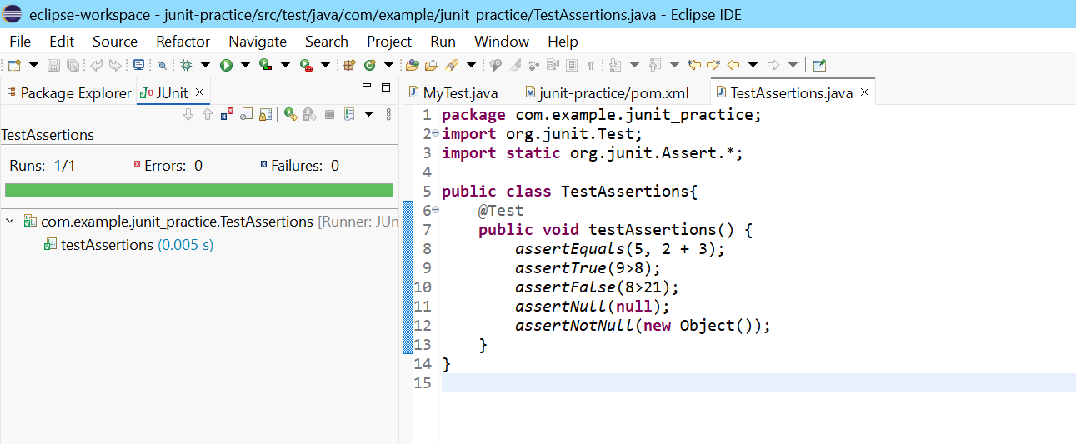

**Exercise 4: Arrange-Act-Assert (AAA) Pattern, Test Fixtures, Setup and Teardown Methods in JUnit**

**Scenario:**  
You need to organize your tests using the Arrange-Act-Assert (AAA) pattern and use setup and teardown methods.

**Steps:**

1. Write tests using the AAA pattern.
2. Use @Before and @After annotations for setup and teardown methods.

**SOLUTION:**



